## **PRACTICAL 1 : WRITE A PYTHON PROGRAM TO CALCULATE THE AREA OF A RECTANGLE BY** **ASSIGNING VALUES TO LENGTH AND BREADTH AS WELL AS TAKING INPUT FROM THE USER.**

## **1.**

### length = 50

### breadth = 20

### area = length * breadth

### print(area)

## **OUTPUT:**

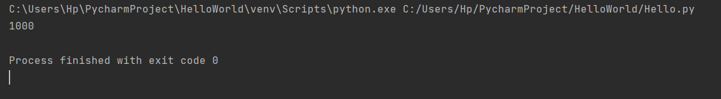

## **2.**

### length = int(input("Enter length: "))

### breadth = int(input("Enter breadth: "))

### area = length * breadth

### print(area)

## **OUTPUT:**

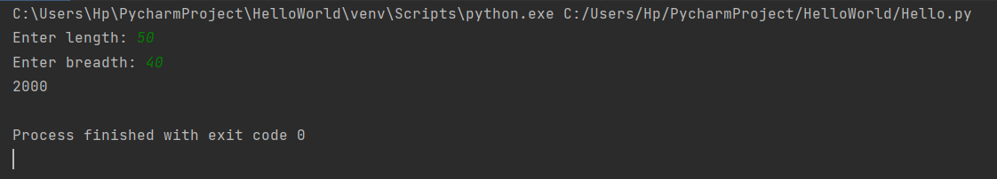

## **PRACTICAL 2 : WRITE A PYTHON PROGRAM TO SWAP TWO NUMBERS USING TEMP VARIABLES AND MULTIPLE ASSIGNMENTS.**

## **1.**

### a = 20

### b = 40

### print("Before swapping",a,b)

### temp = a

### a = b

### b = temp

### print("After swapping",a,b)

## **OUTPUT:**

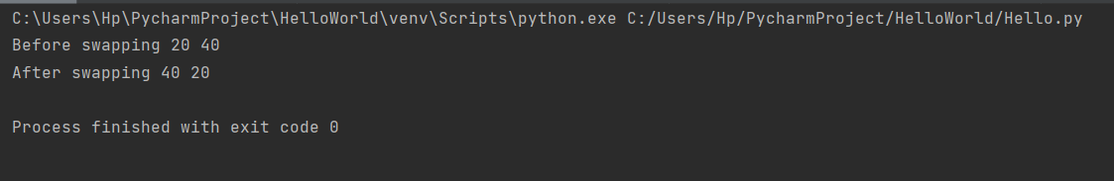

## **2.**

### a = 20 b = 40 print("Before swapping",a,b) a,b = b,a print("After swapping",a,b)

## **OUTPUT:**

